

Method Statement

For

Conduit, Trunking and Tray Installation

At

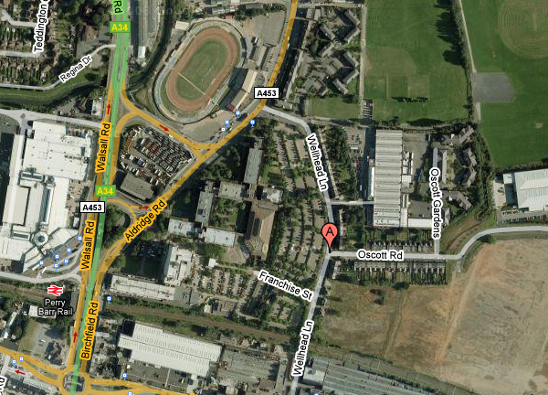 | Perry Barr Sports Centre  Aldridge Road  Perry Barr  B42

Revision Record
Status (revision) | Prelim | Rev A
Date | 03.02.09 | 05.02.09
Author | Darren Bedson | Darren Bedson
Checked by (BPA)
Approved by (PC)
Note:
This method statement has been compiled based on information provided by Comsite Projects Ltd. It is a live document and must be reviewed and modified, as necessary, to take into account significant changes imposed by the Client, the Principal Contractor, the contract, the environment changes in methodology or any other element that may affect the safe execution of works as far as it applies to the project and those affected by the activities associated with the project before work commences.
Provision is made within Section 9.0 of the method statement for adding additional site information and alterations.

Client | Rok Sol Construction |  | MS Ref. | MS001-Rev A
Project | Installation of Conduit & Trays |  | Project Ref. | HS81076
Site | Perry Barr Sports Centre, Aldridge Road |  | Date | 05.02.09
Item No. |  | Schedule
1.0 |  | Introduction  The following method statement and associated risk assessment has been produced to cover the installation of Conduit, Trunking and Trays. The assessments of risk for each area of work are required to be issued prior to commencement of works.  This method statement is to be read in conjunction with the Risk Assessment and any specifications, scopes of work, schedules and drawings prepared for the projects.
2.0 |  | Personnel Involved  - Comsite Contracts Manager – Russell Moss Mob: 07813 105623  - Comsite Site Manager – Gordon Bayliss Mob: 07973 158226
3.0 |  | Schedule of Equipment  - Podiums Steps or Towers  - Hand tools  - Portable equipment
4.0 |  | Schedule of PPE  - Safety hats (mandatory for the task)  - Safety footwear (mandatory for the site)  - Hi-Vis Vest/Coat (mandatory for the site)  - Safety Goggles / Glasses (mandatory for the task)  - Gloves (mandatory for the site)  Note:  - All PPE to be selected for its suitability to overcome a particular risk.  - All PPE to be maintained in a good condition.  - Site Supervisors to provide identification vest (HiViz )for all operatives  NOTE: All activities undertaken within this Method Statement WILL take into account the site requirements laid down within the attached Risk Assessments and the Health & Safety Plan. No work will commence until the above document has been read and fully committed to by the site supervisor and the operatives.
5.0 |  | Sequence of Operation  - Work will be undertaken by Comsite operative’s who will attend a site specific Induction given by the Client so that he has been made aware of any risk or safety issues for the site and identify where the assembly point is located.  - The induction sheets, method statement and risk assessment will be signed by the operative’s when they have undertaken the induction and, read and understood the documents.  - Check equipment and power tools before use.  - Set out positions for installation and fixing points.  - Full attention will be paid to where the Conduits, Trunkings and Trays are being run and that no accidental contact is given to existing services or structure.  - Any conduits to be run within walls shall have routes marked by electricians to enable the builder to chase out.  - Make good areas required which have been affected by work carried out.  - Clear away tools, materials and accumulated rubbish to keep area clean and tidy.
6.0 |  | - The methods considered within the RA should be adopted or adjusted to suit the site conditions. If adjustments are made, notes of these should be added to the RA and to this MS.  - Russ Moss or Gordon Bayliss to discuss any required adjustments with BPA.
7.0 |  | General Considerations  - No work is to be carried out by contractors until they have read, understood, signed and dated all method statements, risk assessments, COSHH assessments and drawings associated with the task they are undertaking.  - All staff and visitors shall be made aware of the current work situation and hazards that may be present before entering the work area.  - Carry out task in accordance with specification of works and ensure no accidental contact is made with existing structure or services.  - See details contained within the attached Risk Assessment covering the importance of the various issues.
8.0 |  | Assessment of Risk  See separate risk assessment
9.0 |  | Site Variations  (To be completed on site for any unforeseen eventuality, agreed and countersigned by the Client, Site Supervisor or Building Owner).

9.0 | Acceptance of Method Statement and Risk Assessment  (The method statement, associated risk assessment and safety guidance shall be read and signed in the space below by all persons undertaking tasks covered by the scope and definition of the project on the understanding that they have understood the hazards involved and the precautions to be taken to mitigate risk to themselves and any other persons who may be affected by the tasks being performed.)
Doc Ref: | MS001 Installation of Conduit Trays Rev A 05.02.09
 | Name (print) | Signature | Company | Date

Comments

- All contractors shall be competent within their own areas of expertise and shall deploy safe working methods at all times.
- All sub contractors must be instructed as to their requirements whilst on site to comply with the Clients site rules the requirements set out by Agile and the requirements to ensure public safety at all times.

